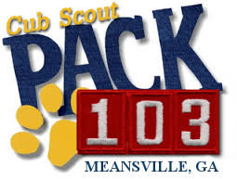
Chartered by the Holly Grove Ruritan Club
3022 Crewsville Road
Bumpass, VA 23024
Est. August 31, 2016
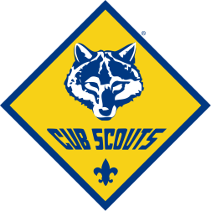
NOTE: This calendar is a planning tool for Pack members. The Pack Committee and Leadership will share specific details to the Pack Membership about all upcoming activities prior to each event. Additional activities will likely be added through the Pack year as opportunities arise.

Bumpass, VA

2018-2019 Activity Calendar*
* Tentative – final dates will be announced by the Pack Committee

September 2018
1 Popcorn/Peanut Sale- Dickenson’s Store
8 Popcorn/Peanut Sale- Lowe’s Zion Crossroads
15 Popcorn/Peanut Sale- Owens Creek Store
22 Popcorn/Peanut Sale-Big Cheese Pizza Lake Anna
29-30* Fall Family Campout –Buckner/Bumpass Park

October 2018
6* Brunswick Stew Fundraiser- Ruritan Hall
13 Apple Harvest Cub Fun Day- Fluvanna
(Webelos can spend the night with Troop 183)
20 * Popcorn/Peanut Sale Parrish’s Grocery
27-Nov 2 Scouting for Food- food collection for food bank

November 2018
5 * Service Project- Spruce Up Ruritan Hall & Work on
Christmas Parade Entry- Ruritan Hall
17* First Responder/Police Visit – Bumpass
25* Work on Christmas Parade Entry- Ruritan Hall

December 2018
1 Louisa Christmas Parade- Louisa
9* Massanutten Scout Ski Day- Massanutten Resort
January 2019
5* Ring in the New Year- Ice Skating/Winter Activity-TBD
19* Nursing Home Visit/ Service Project
*Scout Aquatics planned at UVA Jan./Feb time frame

February 2019
10* Blue and Gold Banquet- Holly Grove Ruritan Hall
10* Arrow of Light Scout Graduation- Ruritan Hall

March 2019
2* Pinewood Derby- Holly Grove Ruritan Hall

April 2019
27-28* Cub Scout Aviation Day- Gordonsville Airport

May 2019
10* Scout Night at the Diamond- Richmond
19* End of Year Bridging/Picnic- Holly Grove Ruritan

Summer 2019*
June- Fishing event
July- Point of Interest Trip
August – Pool Party
Cub Weekend Camp- Camp Brady Saunders/Goochland

